
PB-T2/GEQP/1221/A 17-MAR-2022
PRE BOARD EXAMINATION – TERM II (2021-22)
Subject: GEOGRAPHY  Grade: XII |  |  |  | Max. Marks: 35  Time: 2 Hrs
Name: |  | Section: Roll No:

GENERAL INSTRUCTIONS-
I. Question paper is divided into 5 sections A ,B,C,D&E

II. In section A question number 1 to 3 are Very Short Answer type questions.
III. In section B question number 4 is Source based question
IV. In section C question number 5 & 6 are Short Answer based questions.
V. In section D question number 7 to 9 are Long Answer based questions.

VI .In section E question number 10 is a Map based question.
SECTION A
(VSA)
1. | Write the meaning of ‘Digital Divide’. |  |  |  |  | 2
2. | What is ‘Trans- Continental Railway’. Give an example. |  |  |  |  | 2
3. | Bring about any one major comparison between ‘Urban and Rural marketing centers’ an example each. |  |  |  |  | 2
 | OR
What is the nature of work against the following colour?
(i) Gold
(ii) Blue
SECTION B
SOURCE BASED QUESTION
4 | Read the case study given below and answer the questions that follow:  The challenge of sustainable development requires integration of quest for economic development with environmental concerns .Traditional methods of resource use result into generating enormous quantity of waste as well as create other environmental problems. Hence, sustainable development calls for the protection of resources for the future generations. There is an urgent need to conserve the resources. The alternative energy sources like solar power, wind, wave , geothermal energy are inexhaustible resource .These should be developed to replace the exhaustible resources. In case of metallic minerals, use of scrap metals will enable recycling of metals. Use of scrap is especially significant in metals like copper, lead and zinc in which India’s reserves are meagre. Use of substitutes for scarce metals may also reduce their consumption. Export of strategic and scarce minerals must be reduced, so that the existing reserve may be used for a longer period.
4.1 | What is sustainable development? |  |  |  |  | 1
4.2 | Write any two measures to conserve resources. |  |  |  |  | 1
4.3 | Why conventional sources of energy must be conserved? |  |  |  |  | 1
SECTION C
SHORT ANSWERS
5. | Elucidate the statement- ‘Satellite and communication brought about revolutionary changes in the field of communication’. |  |  |  |  | 3
6. | Identify the given below water way. |  |  |  |  | 1+2
 | How has this water way been a boon for those countries through which it passes?
 | 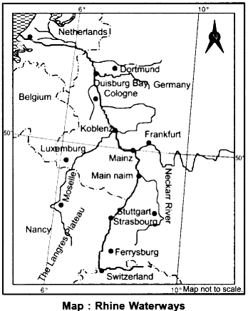
 | OR
 | 'Africa has immense natural resources and yet it is industrially the most backward continent'. Comment.
SECTION D
LONG ANSWERS
7 | How do Quaternary services differ from Tertiary services? Give three reasons why the service sector in developing and developed countries is growing faster than the manufacturing sector? |  |  |  |  | 2+3
8 | How is the use of plastic bags harmful for environmental degradation? Evaluate it by citing suitable reasons. |  |  |  |  | 5
 | OR
 | The disposal of urban waste has become a serious concern for the local authorities. Analyze the statement with suitable examples.
9 | Attaining Sustainable development in the command area requires major thrust upon the measures to achieve ecological sustainability. Highlight the measures proposed to promote sustainable development in the command area of Indira Gandhi Rajasthan Canal. |  |  |  |  | 5
 | SECTION E  MAP QUESTIONS |  |  |  |  | 2+3
10.1 | Identify the following on the political map of the world.  A. A major airport  B. A major sea port.  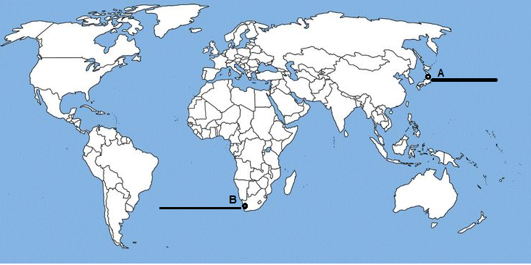
10.2 | On the outline map of India indicate and mark the following features (Attempt any 3). 1x5=5  - Iron ore mines in Karnataka  - Manganese mine  - Coal mine in Tamil Nadu  - Oil field in Uttar Pradesh
Name: |  |  | Section: |  | Roll No:
